INTRODUCTION TO JAVA AND ITS ARCHITECTURE

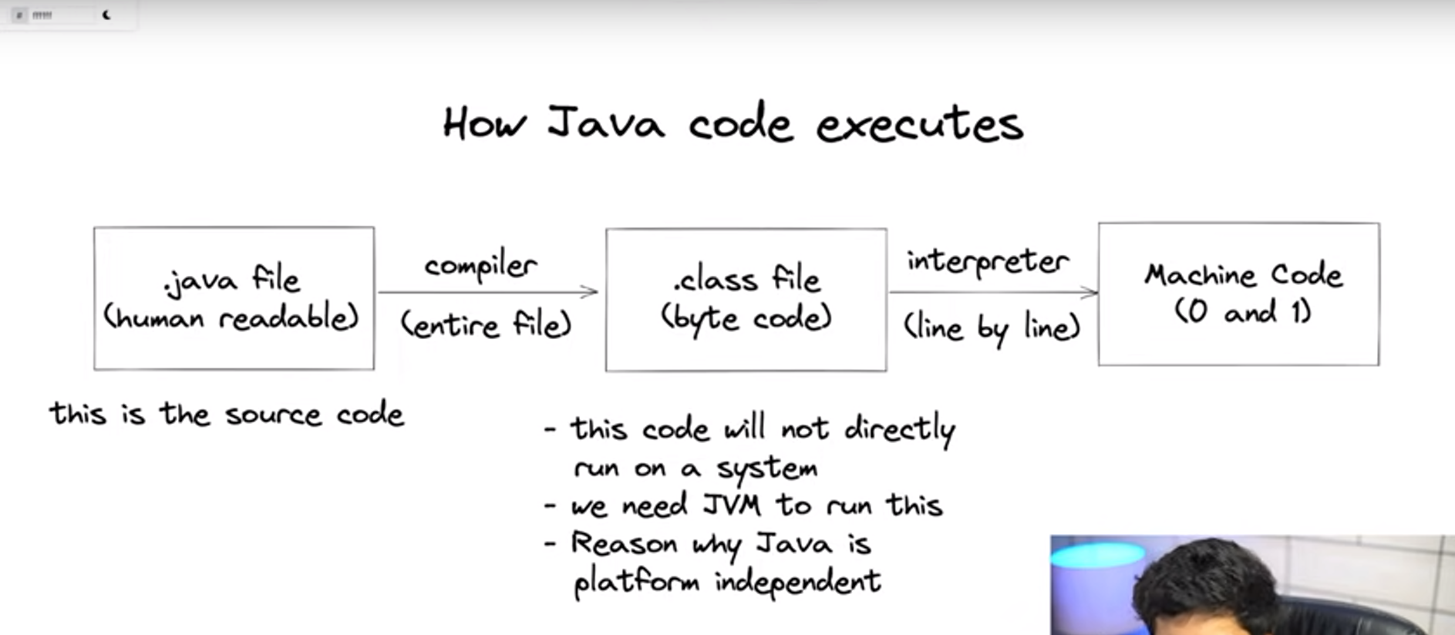

Source code file compiled into byte code (.class file) by using compiler

Interpreter = compiles the code line by line

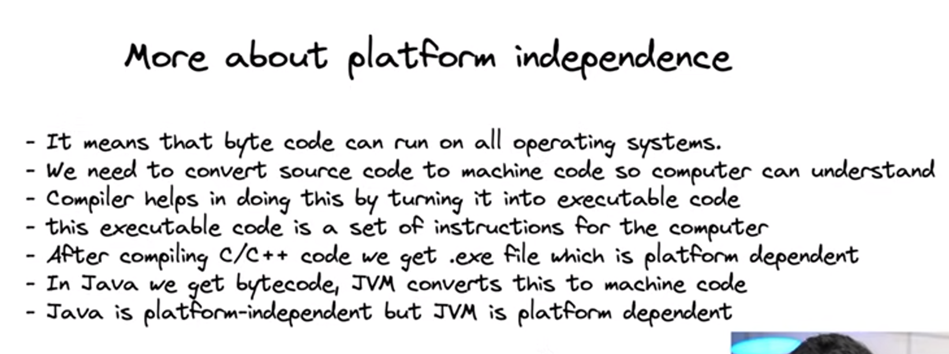

Platform Independence means = Byte code can runs the All Machines

What is meant by compilations ?

* Converting Source code into Machine code (executable code)

**JVM converts the Byte Code into Machine Code**

*Jvm is Platform dependent*

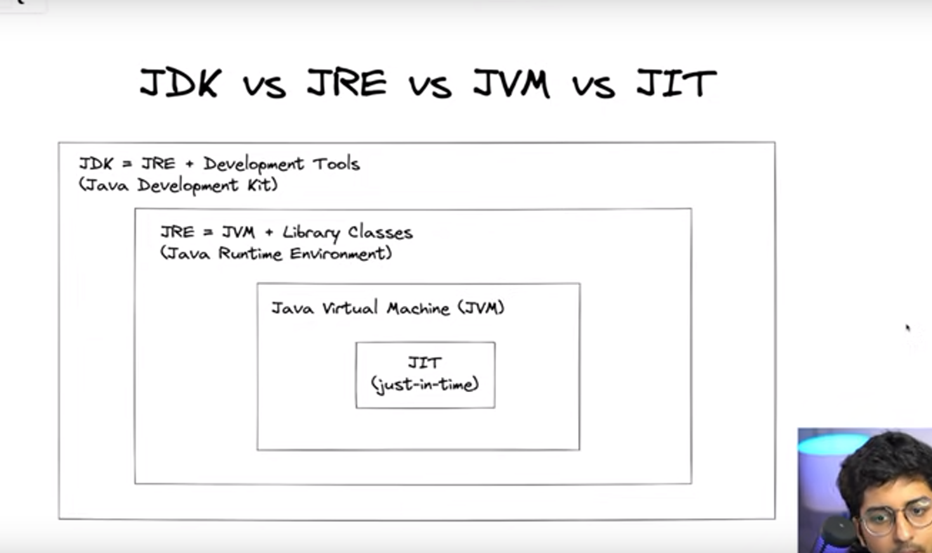

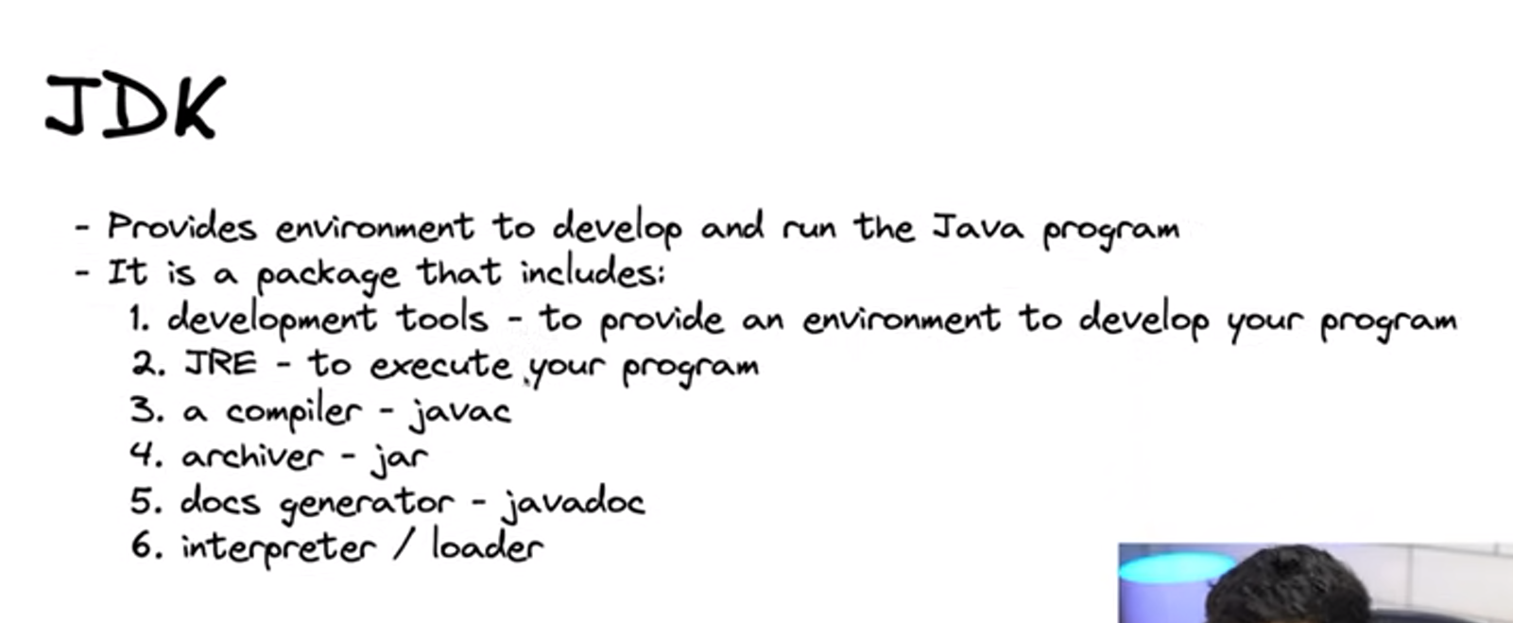

Java code into Byte Code = It is done by javaC

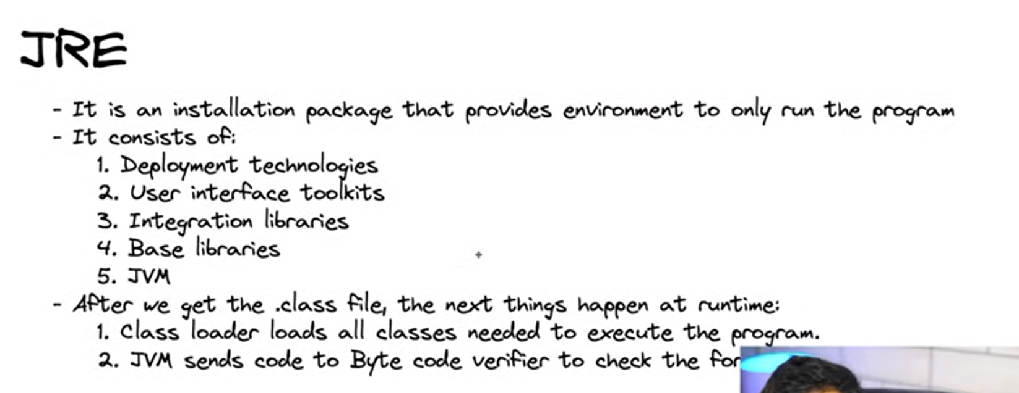

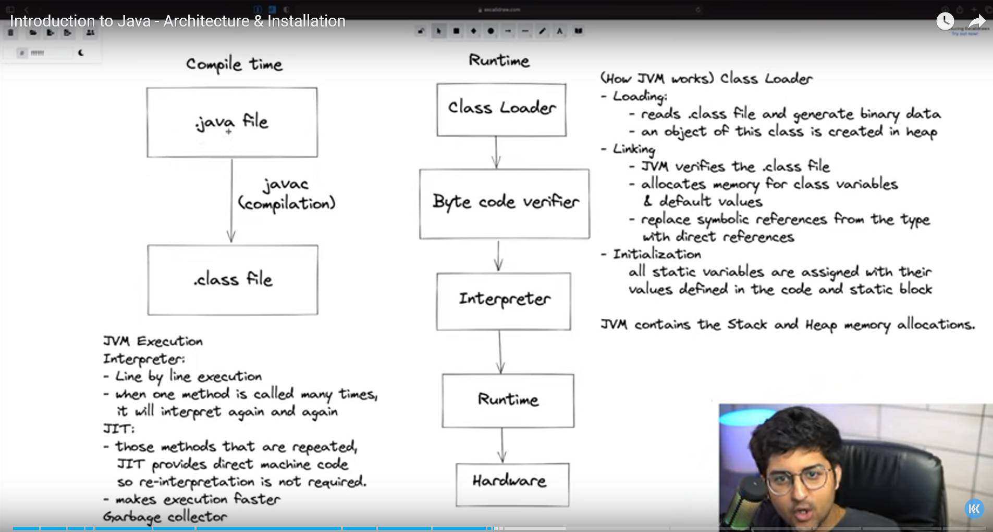

Static variables are object independent

